**[Transportation](https://www.bizjournals.com/boston/news/transportation/)**

**Viewpoint: Another transit contracting lesson learned**

[[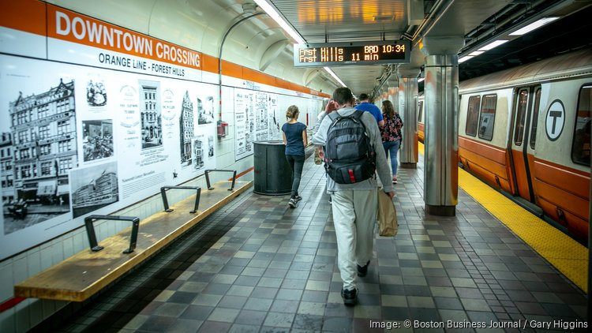](https://www.bizjournals.com/)](https://www.bizjournals.com/)

[Enlarge](https://www.bizjournals.com/)

Governments must look to the private sector to access the technologies needed for services like modern fare-collection systems, but the MBTA’s travails teach us that when they do, their due diligence should include making sure the applicable markets have enough competition to allow them to hold… [more](https://www.bizjournals.com/)

GARY HIGGINS / BOSTON BUSINESS JOURNAL

Mar 3, 2023

As delays and cost overruns mount and the bottom line balloons toward $1 billion, it’s time for state transportation officials to draw lessons from the MBTA’s contract with Cubic Corp. to provide electronic ticketing services. The T originally signed the $723 million contract in 2017, and the project was to be completed by May 2021.At the time, the MBTA was the [largest U.S. transit system that wasn’t a Cubic customer.](https://www.cubic.com/news-events/news/cubic-selected-contract-boston-mbta-deliver-next-generation-fare-payment-system)

And that just might be the nub of the problem.

Fast forward to today and the Cubic contract has thus far ballooned by more than $200 million, to $935 million.  The company now says the project will [“be rolled out in stages by 2025.”](https://www.bostonglobe.com/2020/04/27/metro/mbtas-new-fare-system-will-cost-930-million-big-increase-previous-estimates/) The T hasn’t offered an update since the changes were approved in 2020, and few observers believe that either the price or the deadline remain realistic.

Once complete, the MBTA expects the new system will be applicable to ferry and commuter rail in addition to subways and buses, and provide [flexibility to charge different fares](https://www.bostonglobe.com/metro/2018/10/16/new-technology-could-radically-reshape-mbta-fare-policies/iLvF9LhvDwJrPgfaCWRFaM/story.html?p1=Article_Inline_Text_Link) based on time of day. The system is also supposed to make for faster boarding of buses, subways, boats and trolleys.  All are welcome upgrades for T riders.

But the new system now also appears likely to [increase fare evasion losses](https://pioneerinstitute.org/pioneer-research/the-mbtas-looming-bus-and-green-line-fare-evasion-crisis/), despite initial claims that that it would reduce evasion by $35 million over a decade.

Boston isn’t alone in hiring Cubic to undertake a dramatic overhaul of its fare system – and getting years of delay and massive cost overruns instead.

The New York Metropolitan Transportation Authority also selected Cubic for a project similar in scope to what is planned for the MBTA. Just like in Boston, Cubic cites technological issues as it announces [cost overruns and completion delays](https://www.mobility-payments.com/2022/10/27/new-yorks-mta-says-omny-rollout-falls-further-behind-schedule-cites-vendor-quality-control-among-other-issues/). New York now faces a $100 million cost increase from Cubic and a two-and-a-half-year delay in completion.

The moral of the story is Cubic’s domination of the fare-collection market means customers like the MBTA have little recourse when the company makes promises it can’t keep.

The T – and its customers – have watched the same dynamic play out in another area with its purchase of new Red and Orange Line vehicles.

Governments must look to the private sector to access the technologies needed for services like modern fare-collection systems. But the MBTA’s travails teach us that when they do, their due diligence should include making sure the applicable markets have enough competition to allow them to hold contractors accountable.

[*Charles Chieppo*](https://www.bizjournals.com/boston/search/results?q=Charles%20Chieppo)*is a senior fellow at Pioneer Institute, a Boston-based public policy think tank.*